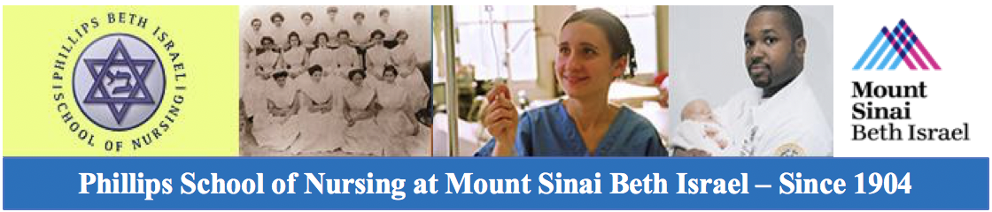
Landing Page https://www.mountsinai.org/locations/beth-israel/pson/alumni

PSON Alumni Association Cordially invites you and your Guests

The Annual Alumni Luncheon celebrating 114 Years!

Sunday, October 21, 2018 from 1:00-5:00 PM
The Water Club
www.thewaterclub.com
500 East 30th Street @ the East River
New York, NY 10016

This year we will honor the Classes of ‘1948, 1958, 1968, 1978, 1988, 1998, 2008’
RSVP and registration by October 5, 2018
Members $25.00 Non-members*/Guests $75.00
Donation for Nurses House (optional) $5.00
*Become a member/renew membership now and pay the luncheon member fee of $25.00
plus membership dues of $50.00 through the coming year 2019 = $75.00

REGISTRATION INFORMATION
- Yes, I will attend the PSON Annual Alumni Luncheon ___________
- I am enclosing an additional donation for Nurses House ___________
- I will be bringing a guest(s) Please provide Name(s): __________________________________________
- Please provide a Kosher meal ______________
- No, I am unable to attend the luncheon this year, yet please accept my donation to the PSON Alumni Association ____
Total Amount Enclosed (electronic or personal check): $________________
**We are accepting PayPal at this time. Go to PayPal.com and submit your payment to alumni.association@mountsinai.org Please add your name, address, phone number, year of graduation, and number of guests in the Comments field
Name: Last: ______________________________ First: ____________________________ M.I. _______
Last Name while attending PSON (if different): ____________ Year of PSON Graduation: ________
Mailing Address: ________________________________________________Apt: ___________________
City: ______________________________________ State: __________________ Zip: _______________
E-mail Address: ______________________________Phone: Home: ______________ Cellular: _____________
Please mail this form and your Registration Fee (electronic and personal checks only) by October 5, 2018 to:
PSON Alumni Association
776 Avenue of the Americas, 4th Fl.
New York, NY 10001-6354
If you have any questions contact PSON Alumni Luncheon Committee at: alumni.association@mountsinai.org

