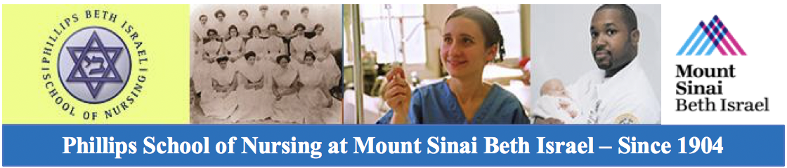
https://www.mountsinai.org/files/MSHealth/Assets/PSON/PBISN%20Alumni%20Benefits_May2016.pdf
Nursing Alumni Association Membership Benefits*

- Free Networking Events (Social and Educational) to keep in touch with former Classmates and Friends and Learn

- Discounted registration for the PSON Annual Fall Meeting and Luncheon Event

- 50% Discount on tuition for Continuing Education (CE) Classes offered through Phillips School of Nursing at Mount Sinai Beth Israel

- $150.00 per calendar year towards registration fees paid to attend a Nursing CE program

- $1000.00 Scholarship offered annually for one qualifying Alumni Member matriculated in an accredited BSN or advanced nursing degree program

- Reimbursement** of up to a maximum of $2000.00 for direct care to Alumni Members for hospital-based privately contracted nursing caregivers

- Private room (pending availability) at the Mount Sinai Beth Israel Medical Center

* Available to all active dues paying PSON Alumni Association members in good standing. Any member who is in default of payment of dues, is not entitled to benefits until one (1) year following reinstatement.
** Eligible after medical insurance reimbursement, and only after submission of original receipts and review by the Alumni Board
Become an active member of the association now by sending your $50.00 Check and a completed Alumni Membership Application Form (found at https://www.mountsinai.org/locations/beth-israel/pson/alumni ) to: PSON Alumni Association - 776 Sixth Avenue 4th Floor, New York, NY 10001
**We are accepting PayPal at this time. Go to PayPal.com and submit your payment to alumni.association@mountsinai.org Please add your name, address, phone number, year of graduation, and number of guests in the Comments field

