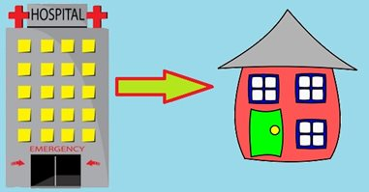

**FAQ: GOING HOME AFTER SURGERY**

**Q:** What time will I be discharged?

**A:** You will go home before noon, so that you get home safe.

**Q:** Do I need a special car to get home?

**A:** Patients go home in all kinds of cars. Physical Therapy will teach you the best ways to get in and out of the car.

**Q:** What services will I go home with, and do I qualify for a home health aide?

**A:** Read more here:

**Q:** What equipment will I need for home, and how do I get it?

**A:** Read more here:

**Q:** Will I go home with pain medication?

**A:** Yes. In the hospital, you will be started on a long acting pain medication and a short acting pain medication.

**Q:** When will my dressing be removed?

**A:** The dressing will stay on for a week after surgery. The dressing can be removed by peeling it off, then the incision can remain open to air.

**TAKING CARE OF YOURSELF AT HOME**

**DRESSINGS**

On the day you leave your dressing will be changed. Leave this dressing on for a week, then remove it and leave the wound uncovered. If there is any drainage or the dressing is saturated, apply a dry dressing and call your surgeon immediately.

**BATHING**

You can shower with the dressing on. When it is removed, pat the area dry with a clean towel after showering.

**DRIVING**

It is not safe for you to drive after surgery. Please ask your surgeon when it is safe for you to begin driving again.

**RETURNING TO WORK**

Your surgeon can help you decide when to return to work.

**WHAT TO EXPECT**

You may notice some swelling in your leg. This is normal. Ice, elevation, and compression stockings can help. Call your surgeon if you have any concerns.